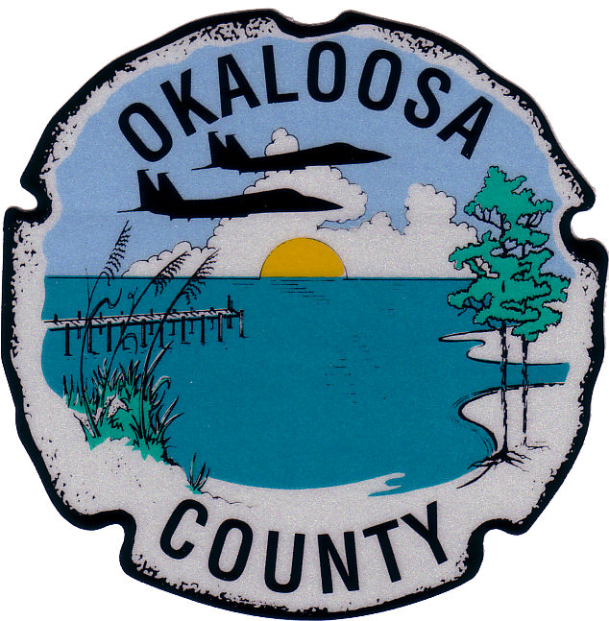

Okaloosa County
News Release

Chairman Carolyn Ketchel to host Town Hall in Shalimar
to discuss Stormwater Improvements
Okaloosa County Commission Chairman Carolyn Ketchel will host a town hall style meeting on August 16th to discuss potential stormwater improvements, and to hear the concerns of district residents. The meeting will take place at 5:30 in the evening at the Shalimar Pointe Golf Course Clubhouse.
The meeting will include Chairman Ketchel and other county officials tasked with continuing to improve stormwater drainage and facilities in Okaloosa County, specifically the Shalimar area, District 2, Commissioner Ketchel’s district.
The meeting will be open to the public, and anyone who wishes to voice comments will be given the opportunity. Local media are also invited and encouraged to attend.
Commissioner Ketchel says she hopes all residents will be involved with the town hall meeting, “to consider the next steps that will be taken to improve drainage for the area. We are asking for citizen input, as this is their community.”

###

Robert L. Brown III
Public Information Officer
850.651.7270; fax 651.7551
rbrown@co.okaloosa.fl.us
www.okaloosafl.us
1250 N. Eglin Parkway
Shalimar, Fl., 32579

Please Note: Email communication may be subject to public disclosure if requested, due to Florida's public records laws concerning written communication.

